|  |  |
| --- | --- |
| **Status** | Finished |
| **Started** | Tuesday, 26 November 2024, 5:33 PM |
| **Completed** | Tuesday, 26 November 2024, 11:23 AM |
| **Duration** | 25 days 6 hours |

Top of Form

Question **1**

Correct

Marked out of 3.00

Flag question

Question text

A set of N numbers (separated by one space) is passed as input to the program. The program must identify the count of numbers where the number is odd number.

Input Format:

The first line will contain the N numbers separated by one space.

Boundary Conditions:

3 <= N <= 50

The value of the numbers can be from -99999999 to 99999999

Output Format:

The count of numbers where the numbers are odd numbers.

Example Input / Output 1:

Input:

5 10 15 20 25 30 35 40 45 50

Output:

5

Explanation:

The numbers meeting the criteria are 5, 15, 25, 35, 45.

Answer:(penalty regime: 0 %)

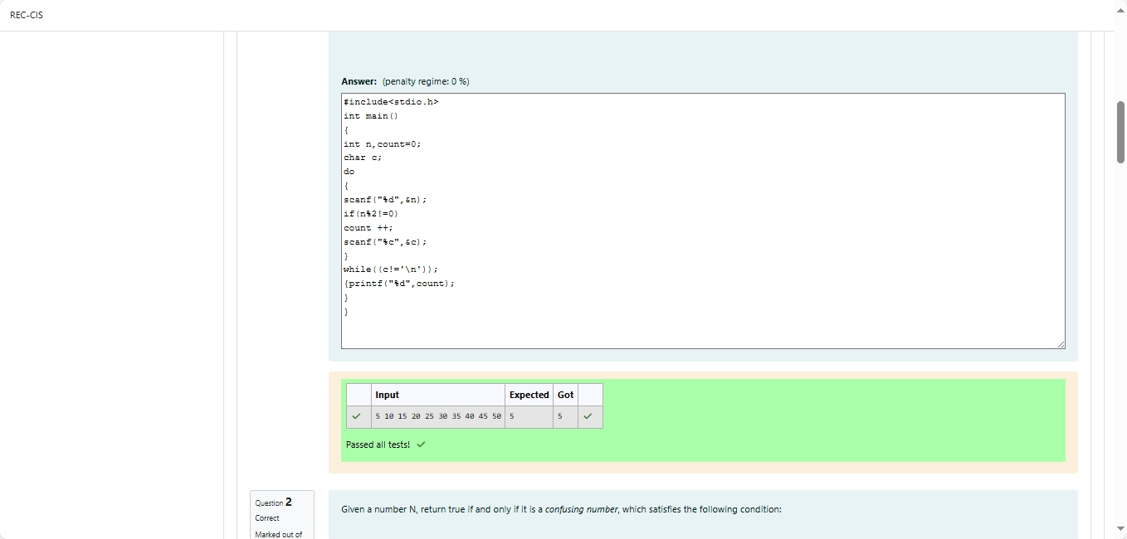

Question **2**

Correct

Marked out of 5.00

Flag question

Question text

Given a number N, return true if and only if it is a *confusing number*, which satisfies the following condition:

We can rotate digits by 180 degrees to form new digits. When 0, 1, 6, 8, 9 are rotated 180 degrees, they become 0, 1, 9, 8, 6 respectively. When 2, 3, 4, 5 and 7 are rotated 180 degrees, they become invalid. A *confusing number* is a number that when rotated 180 degrees becomes a **different** number with each digit valid.

**Example 1:**

6 -> 9

Input: 6

Output: true

Explanation:

We get 9 after rotating 6, 9 is a valid number and 9!=6.

**Example 2:**

89 -> 68

Input: 89

Output: true

Explanation:

We get 68 after rotating 89, 86 is a valid number and 86!=89.

**Example 3:**

11 -> 11

Input: 11

Output: false

Explanation:

We get 11 after rotating 11, 11 is a valid number but the value remains the same, thus 11 is not a confusing number.

**Note:**

1.      0 <= N <= 10^9

2.      After the rotation we can ignore leading zeros, for example if after rotation we have 0008 then this number is considered as just 8.

Answer:(penalty regime: 0 %)

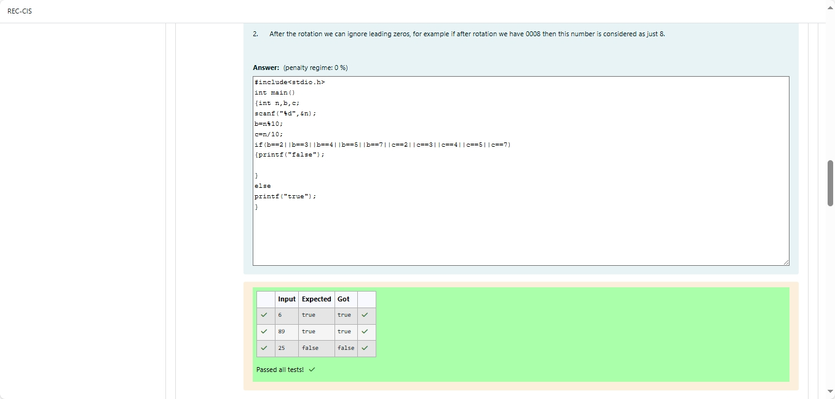

Feedback

Question **3**

Correct

Marked out of 7.00

Flag question

Question text

A nutritionist is labeling all the best power foods in the market. Every food item arranged in a single line, will have a value beginning from 1 and increasing by 1 for each, until all items have a value associated with them. An item's value is the same as the number of macronutrients it has. For example, food item with value 1 has 1 macronutrient, food item with value 2 has 2 macronutrients, and incrementing in this fashion.

The nutritionist has to recommend the best combination to patients, i.e. maximum total of macronutrients. However, the nutritionist must avoid prescribing a particular sum of macronutrients (an 'unhealthy' number), and this sum is known. The nutritionist chooses food items in the increasing order of their value. Compute the highest total of macronutrients that can be prescribed to a patient, without the sum matching the given 'unhealthy' number.

Here's an illustration:

Given*4*food items (hence value: *1,2,3* and *4*), and the unhealthy sum being *6* macronutrients, on choosing items *1, 2, 3* -> the sum is *6,* which matches the 'unhealthy' sum. Hence, one of the three needs to be skipped. Thus, the best combination is from among:

·         *2 + 3 + 4 = 9*

·         *1 + 3 + 4 = 8*

·         *1 + 2 + 4 = 7*

Since*2 + 3 + 4 = 9,*allows for maximum number of macronutrients, 9 is the right answer.

Complete the code in the editor below. It must return an integer that represents the maximum total of macronutrients, modulo *1000000007 (109 + 7)*.

It has the following:

*n:* an integer that denotes the number of food items

*k:* an integer that denotes the unhealthy number

**Constraints**

·         *1 ≤ n ≤ 2 × 109*

·         *1 ≤ k ≤ 4 × 1015*

Input Format For Custom Testing

The first line contains an integer, *n*, that denotes the number of food items.

The second line contains an integer, *k*, that denotes the unhealthy number.

**Sample Input 0**

2

2

**Sample Output 0**

3

**Explanation 0**

The following sequence of *n = 2*food items:

1.      Item 1 has 1 macronutrients.

2.      *1 + 2 = 3*; observe that this is the max total, and having avoided having exactly *k = 2*macronutrients.

**Sample Input 1**

2

1

**Sample Output 1**

2

**Explanation 1**

1.      Cannot use item *1* because *k = 1* and *sum ≡ k* has to be avoided at any time.

2.      Hence, max total is achieved by *sum = 0 + 2 = 2*.

Sample Case 2

**Sample Input For Custom Testing**

**Sample Input 2**

3

3

**Sample Output 2**

5

**Explanation 2**

*2 + 3 = 5, i*s the best case for maximum nutrients.

Answer:(penalty regime: 0 %)

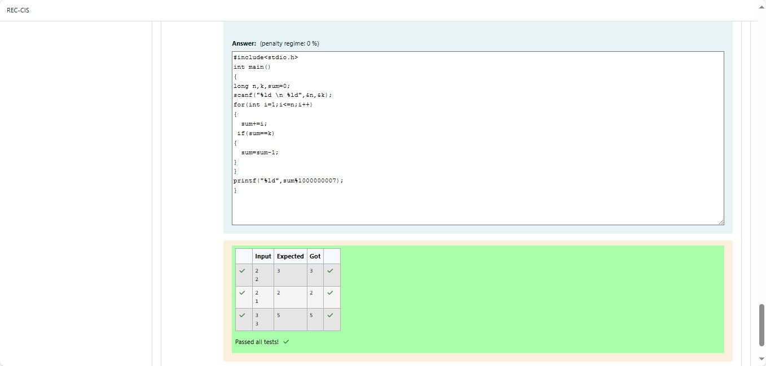Bottom of Form